CHANGE PLANNING TOOLS
(Optional appendix to the Change Plan Template)

Why Change Fails and The Essential Ingredients to Successful and Sustainable Change
Why change fails:  - People don’t like change.  - Lack of clarity about what we are trying to achieve and why  - The implications are not fully understood  - Obsession with process over outcomes  - Inertia  - The project is set up to fail  - Poor communications & disingenuous engagement  - We forget that emotions trump logic every time  - A change-averse culture  - Leadership doesn’t stay the course | Essential ingredients to successful change  - A Change Catalyst to drive delivery  - Complete clarity about what we are trying to achieve and why  - Detailed understanding of the implications of the change  - Laser-like focus on the outcomes  - Find the emotional triggers  - Genuine engagement of people at all levels  - Clear accountabilities, responsibilities and decision making  - A change process that includes a ‘pause for reflection’  - Strong, committed, aligned and unwavering leadership team  - Establish an enabling, change-ready culture

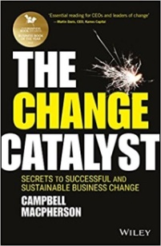

Successful change requires more than a vision …

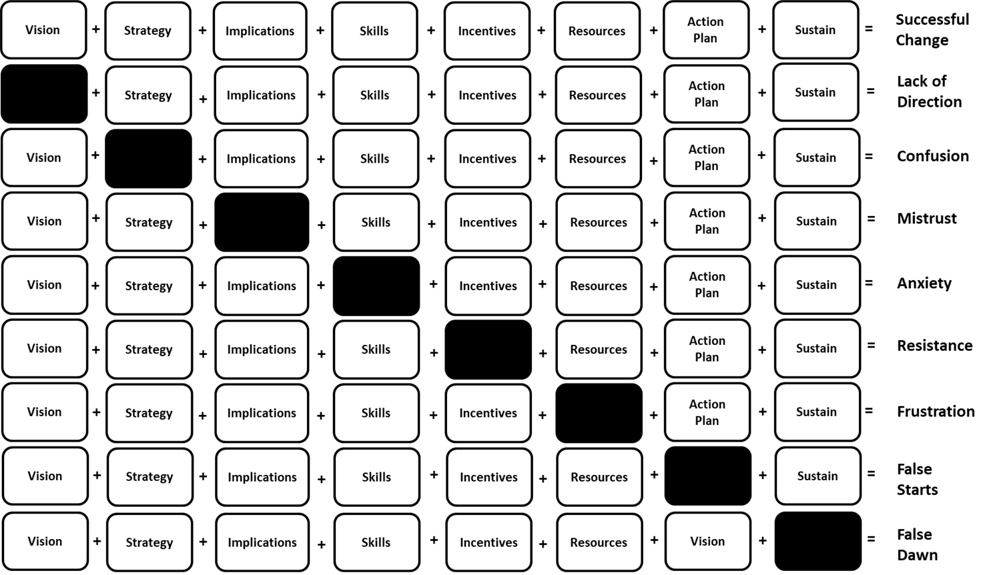
Stakeholder Impact Assessment
High Influence + Low Interest =  Keep Satisfied  Influence | High Influence + High Interest =  Engage Closely
Low Influence + Low Interest =  Monitor | Low Influence + High Interest =  Keep Informed
Interest

Stakeholder Segmentation
 | Advocates  For the change and influential | Acceptors  Likely to go along with the change | Neutrals | Sceptics  Able to be persuaded | Resistors  Against the change | Saboteurs  Against the change and influential
Key Names

Stakeholder Analysis
Stakeholder | Segment  (Advocate - Saboteur) | Impact of the change on them  (L/M/H) | Influence on the project  (L/M/H) | What is important to the stakeholder? | How could the stakeholder contribute to the project? | How could the stakeholder block the project? | Strategy for engaging the stakeholder

